Chapter 9, Problem 67.

At Ω = 10³ rad/s, find the input admittance of each of the circuits in Fig. 9.74.

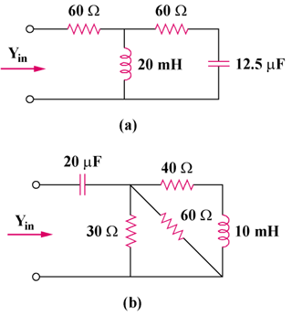

Figure 9.74
For Prob. 9.67.

